3.3.3 Derivatives Worksheets

**Remember that simplifying before attempting to find the derivative is worthwhile**

- Using Leibniz notation , find the derivatives for each of the following functions, using the Quotient Rule when possible.

- Find the equation of the tangent line to the curve at the given value of x.
  - ,

  - ,

- Find the equations of the tangent lines to the curve that are parallel to the line .

- Determine the value of , given that .

- If f is a differentiable function, find an expression for the derivative of the function .

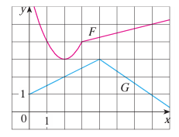
- Let and , where F and G are the functions whose graphs are shown below.
  - Find .

  - Find .

